Organic Rice Production in Camargue, France. A resilience glimpse in turbulent times

Jean-Marc Barbier¹, Jean Claude Mouret¹, Fanny Balma¹, Isabelle Michel¹, Laure Hossard¹, Sylvestre Delmotte¹, Santiago Lopez-Ridaura^{1,2}

¹INNOVATION, Univ Montpellier, CIRAD, INRAE, Institut Agro, Montpellier, France ²Sustainable Agrifood Systems (SAS), International Maize and Wheat Improvement Center (CIMMYT), Mexico

The Camargue, situated in the delta of the Rhône River, is France's most important region for rice production. The Rhône River, one of Western Europe's largest rivers, stretches from the Alps to the Mediterranean Sea in southern France. The Camargue delta is among Europe's largest wetlands, designated as a wetland of international importance under the Ramsar Convention. It is also classified as a UNESCO Biosphere Reserve and Regional Nature Reserve. In this unique and delicate environment, the Camargue is home to over 270 bird species and various other animals and plant species of interest (Pernollet, 2016).
Rice, specifically the japonica type, plays a crucial role in agricultural production in the Camargue. It allows for the cultivation of other crops in this saline environment by desalinating the soil through flood irrigation with fresh water from the Rhône River. Additionally, rice production is economically attractive and serves as a central element for the livelihoods of approximately 200 farm households. Due to regulations on herbicide usage, rice cultivation needs to be rotated with dry crops, primarily wheat, to control weed infestations and achieve yields of approximately 5-7 tons per hectare after a 3 to 5-year rotation.
The Camargue has around 35,000 hectares of agriculturally suitable land, with rice being presently grown on 10,000 to 13,000 hectares annually. Approximately 3,300 hectares of rice in the Camargue are cultivated using organic management methods, involving around 90 farms. This represents approximately 25% of the total rice production in the region. However, this situation hasn't always been the case. In the past 10 to 15 years, overall rice production in the Camargue has halved, while the area under organic management and the number of farmers practicing organic rice production have tripled.
Over a decade ago, we conducted prospective studies, including quantitative and qualitative scenario analyses, to explore potential changes for organic rice production and agriculture in the Camargue (Delmotte et al., 2016; Delmotte et al., 2017). Through participatory approaches, we identified the main drivers and integrated possible, plausible, and probable future situations into a multi-scale and multi-criteria assessment framework. In 2023, we returned to the region and interviewed 15 different farmers and regional actors to understand the current situation, assess the evolution of organic rice production, and evaluate the accuracy of our past scenario assessments.
Our previous scenario assessments highlighted various future situations for agricultural development in the Camargue, including organic rice production. Our analyses identified the discontinuation of subsidies to rice production, as envisioned in the development of the European Common Agricultural Policy (CAP) since 2014, as one of the most significant threats to rice production in the Camargue. Additionally, we recognized a key driver related to the reduction of pesticide usage (including herbicides) in line with France's aim to decrease their use by 50% by 2025 (Plan ECOPHYTO II+, 2018). According to our models, organic agriculture could play a vital role in mitigating the effects of subsidy withdrawal and contribute to the pesticide reduction program. Mixed crop-livestock farmers were found to be in a favorable position to convert to or maintain organic rice production. Furthermore, the diversification of farming and cropping systems appeared inevitable to overcome the aforementioned challenges.
In 2023, we found that these scenario analyses had been relatively accurate. Coupled subsidies for rice had been suppressed, along with further constraints on farmers’ use of pesticides. This saw the cultivated area reduced to around half of the 2009 reference value—as suggested by our scenario assessments—while mixed crop-livestock systems and further diversification of cropping and farming systems were observed throughout the 2014-2022 period.

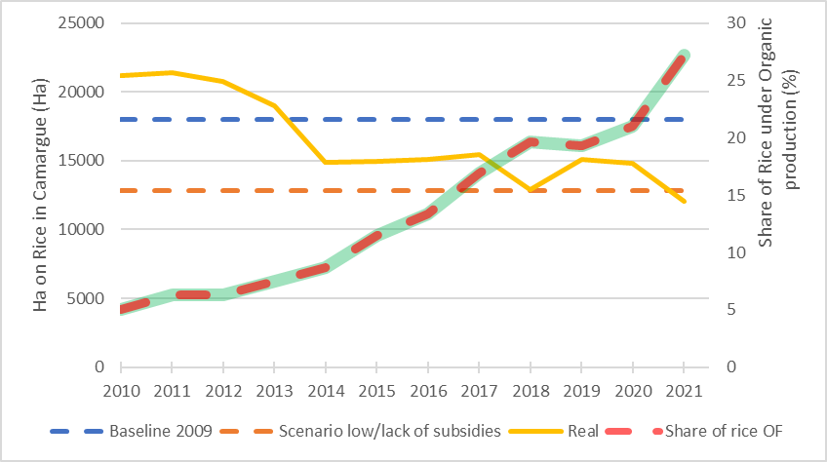

References:
Delmotte S., Barbier J.M., Mouret J.C., Le Page C., Wéry J., Chauvelon P., Sandoz A., Lopez Ridaura S., 2016. Participatory integrated assessment of scenarios for organic farming at different scales in Camargue, France. Agricultural systems 143, 147-158.
Delmotte S., Couderc V., Mouret J.C., Lopez Ridaura S., Barbier J.M., Hossard L., 2017. From stakeholders narratives to modelling plausible future agricultural systems. Integrated assessment of scenarios for Camargue, Southern France. Europ. J. Agronomy 82, 292-307.
Pernollet C.A., 2016. L’utilisation des rizières par les canards hivernants: vers une gestion des rizières en interculture favorable aux canards et aux agriculteurs. Thèse de doctorat, Université Montpellier 2.
Plan ECOPHYTO II+. Ministère de la santé et de la prévention, 65 p. Sept. 2018.

Key words: ex-ante assessment, scenarios, retrospective analysis, systems approaches, participatory
Co-responding author: Jean-Marc Barbier
Position: Scientist
Affiliation: INRAE – UMR Innovation (Montpellier SupAgro, INRAE, CIRAD, University of Montpellier), Montpellier, France
Country: France
E-mail: jean-marc.barbier@inrae.fr

